Modem Initialization Commands

If you are using windows XP and want to remove or
add a modem initialization string do the following.
Click on start:

Then click on Control Panel.

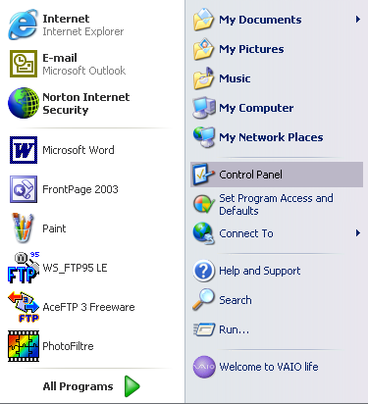

Next find phone and modem options. It should be in
alphabetical order and click on it.
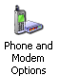

On this screen click on the Modems tab at the top.

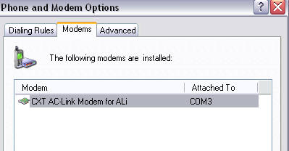

Here click on the properties button at the bottom of the page.

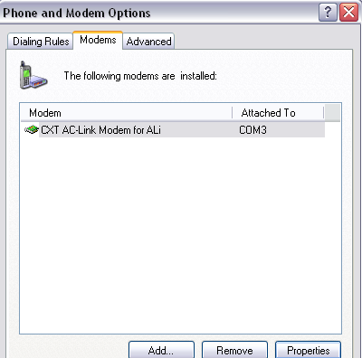

Here is where you add, change, or remove the modem initialization
string.

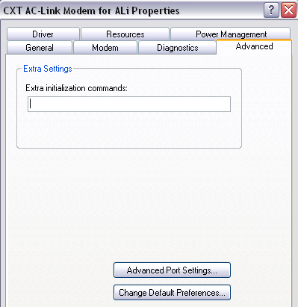

If you are having connection issues and there is an extra initialization
command in the box please remove it and reboot your PC and then
try to connect again. Here is a very good website to help you
more with initialization commands and how to understand them.

http://www.modemhelp.org/inits/

